Event Flow:
Play through:
3 doors, each door leads to Sam’s bedroom at a different age (5,10,15).
Part1:
Teams must explore each room and find misplaced items from a checklist, and return the items to their correct places in time(timeframe).
This the teams must do by panning through Sam’s room and clicking on various items. Once clicked on, the items will showcase some info about it. Using this info the team must decide whether the item is a misplaced one or not.
They must submit a form with the names of the 5 misplaced items. (*last bit is subject to change)
- Age 5 room:
  - drawing clues (distant family)
  - birthday gift clues (apology note from parents)
  - pet dog as only friend
  - bright room filled with a lot of toys
  - a story book (picture book) clue.
- Age 10 room:
  - Video game console
  - DVD’s that can be played on screen (bullying audio file)
  - Family photo frame (some sense of distance between his family)
  - Nanny signed trip form
  - basketball
- Age 15 room:
  - Graduation album (reveals a vandalized page, bully’s page)
  - nanny signed official forms (ielts, sat, etc). Also a visa renewal doc indicating Sam is of Indian origin.
  - Computer is locked. Password required
  - A wilted plant. Gloomy room
  - Posters of games, F1, dog

Part 2:
For this part, the teams are given a crossword puzzle that they need to answer (question, riddles, clues, etc.).
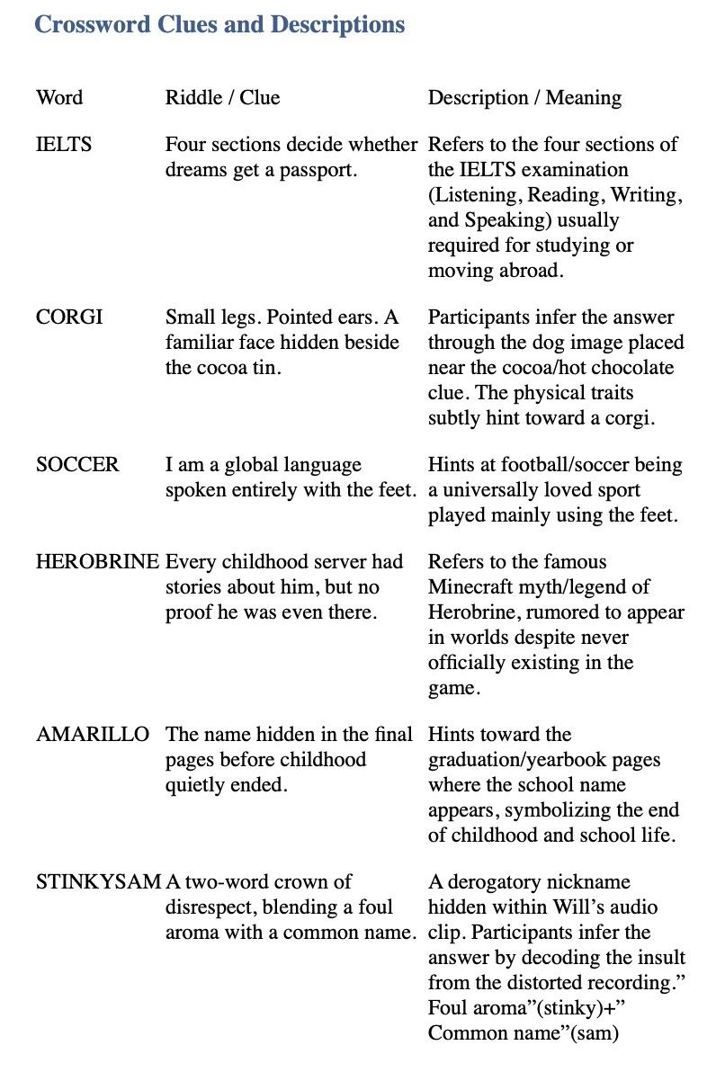
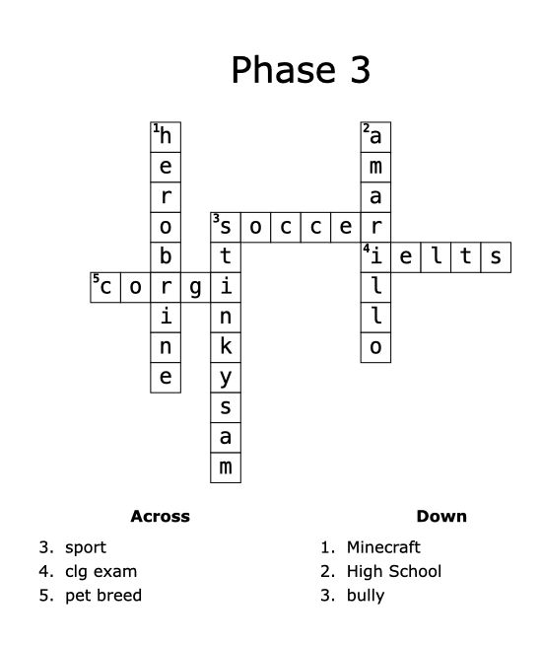
Example:
Colored letters= r, i, t, n, s, e, e, t
Hidden word= interest

Each word corresponds to the blanks in the crossword. Some of the blocks are highlighted in a different color. Once the crossword has been filled, the letters corresponding to the highlighted blocks need to be unjumbled so that they come together to form a meaningful word.
This word works as a password to the computer in the age 15 room.
EXAMPLE: Word is “interest”. It is the password for Sam’s computer
Why go to the computer?
Crucial elements present in computer. Sams most defining memory fragment (or character trait). Like a final puzzle piece.

Part 3:
After entering the password into the computer, the team can access Sam’s computer.
The computer has many files from all over the years (age 0 till age 50); Glitch in timeline created files of all his memories till present. Future file is locked.
Players must use this info to answer a set of questions.

Team split(?):
- Team on computer:
  - this team can explore Sam’s files present on his computer.
  - Like his therapy logs, doctor visits, etc?
- Team on phone:
  - receives a sudden death quiz.
  - Sudden Death: A series of questions being asked by Sam (about himself) to the players (aka his friends).
Both teams must work in unison to carefully answer all the questions.
Even if one question is answered incorrectly it leads to immediate game over (game is aborted).
Future file unlocked:
- CASE 1: If team loses, the game stops and the team receive a doctor’s letter declaring Sam in the present as brain dead since they were unable to recover him.
- CASE 2: Players carefully answered all the questions to reach 100% recovery of Sam. Sam wakes up and is cured of his dementia and starts working towards a full recovery irl.

